Supporting Information
A Deep Learning Framework for Species-Level Identification of Root-Knot Nematodes Using Perineal Pattern Images
Sristi Das^{1#}, Koyel Ghosh^{2,3#}, Sandip Mondal^{1,4#}, Suvasri Dutta¹, Matiyar Rahaman Khan⁵, Utpal Garain^{2,6}, Abhishek Mukherjee^{1,6*}
#These authors have contributed equally
¹ Agricultural and Ecological Research Unit, Indian Statistical Institute, Giridih, Jharkhand - 815 301, India.
² Computer Vision and Pattern Recognition Unit, Indian Statistical Institute, Kolkata, West Bengal, India.
³ School of Computing, College of Engineering and Technology, SRM Institute of Science & Technology, Kattankulathur, Tamil Nadu, India
⁴ Department of Plant Pathology, North Dakota State University, Fargo, ND 58105, USA
⁵ Division of Nematology, Indian Agricultural Research Institute, New Delhi 110012, India.
⁶ Centre for Artificial Intelligence and Machine Learning (CAIML), Indian Statistical Institute, Kolkata, West Bengal, India.
Corresponding author email: Abhishek Mukherjee; amukh@isical.ac.in

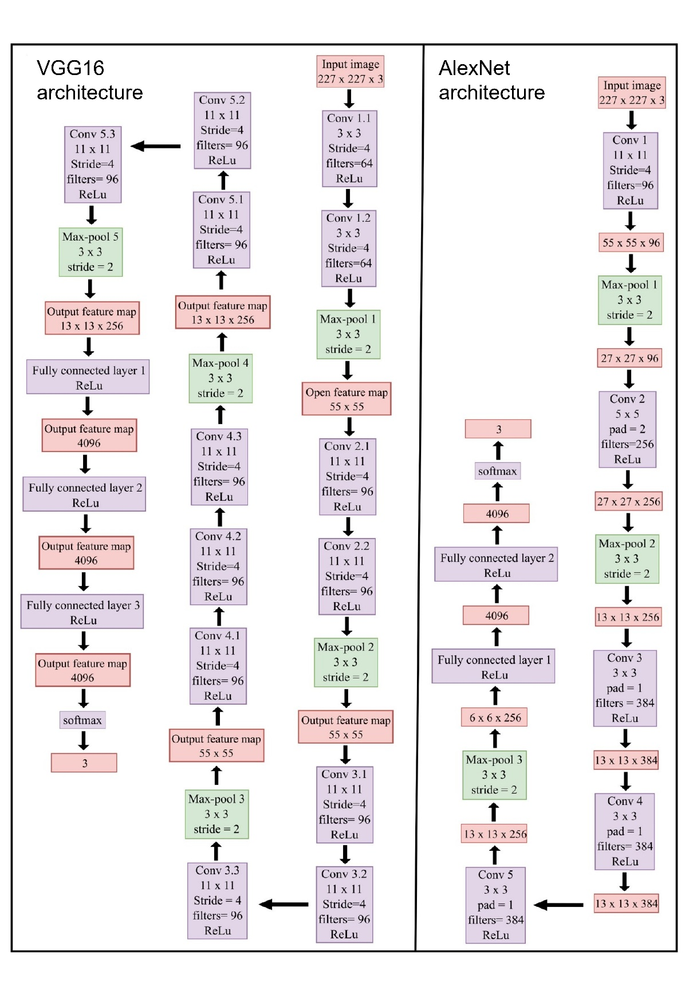

Supplementary Figure S1. Alexnet and VGG16 model architecture

Table S1. Distribution of perineal pattern images across three root-knot nematode species, stratified by species and split into 5-fold for cross-validation: M. graminicola (class 0), M. incognita (class 1), and M. javanica (class 2).
Folds | M. graminicola  (class 0) | M. incognita  (class 1) | M. javanica  (class 2) | Total
F1 | 35 | 14 | 21 | 70
F2 | 35 | 14 | 20 | 69
F3 | 35 | 14 | 21 | 70
F4 | 35 | 14 | 21 | 70
F5 | 34 | 14 | 21 | 69
Total | 174 | 70 | 104 | 348

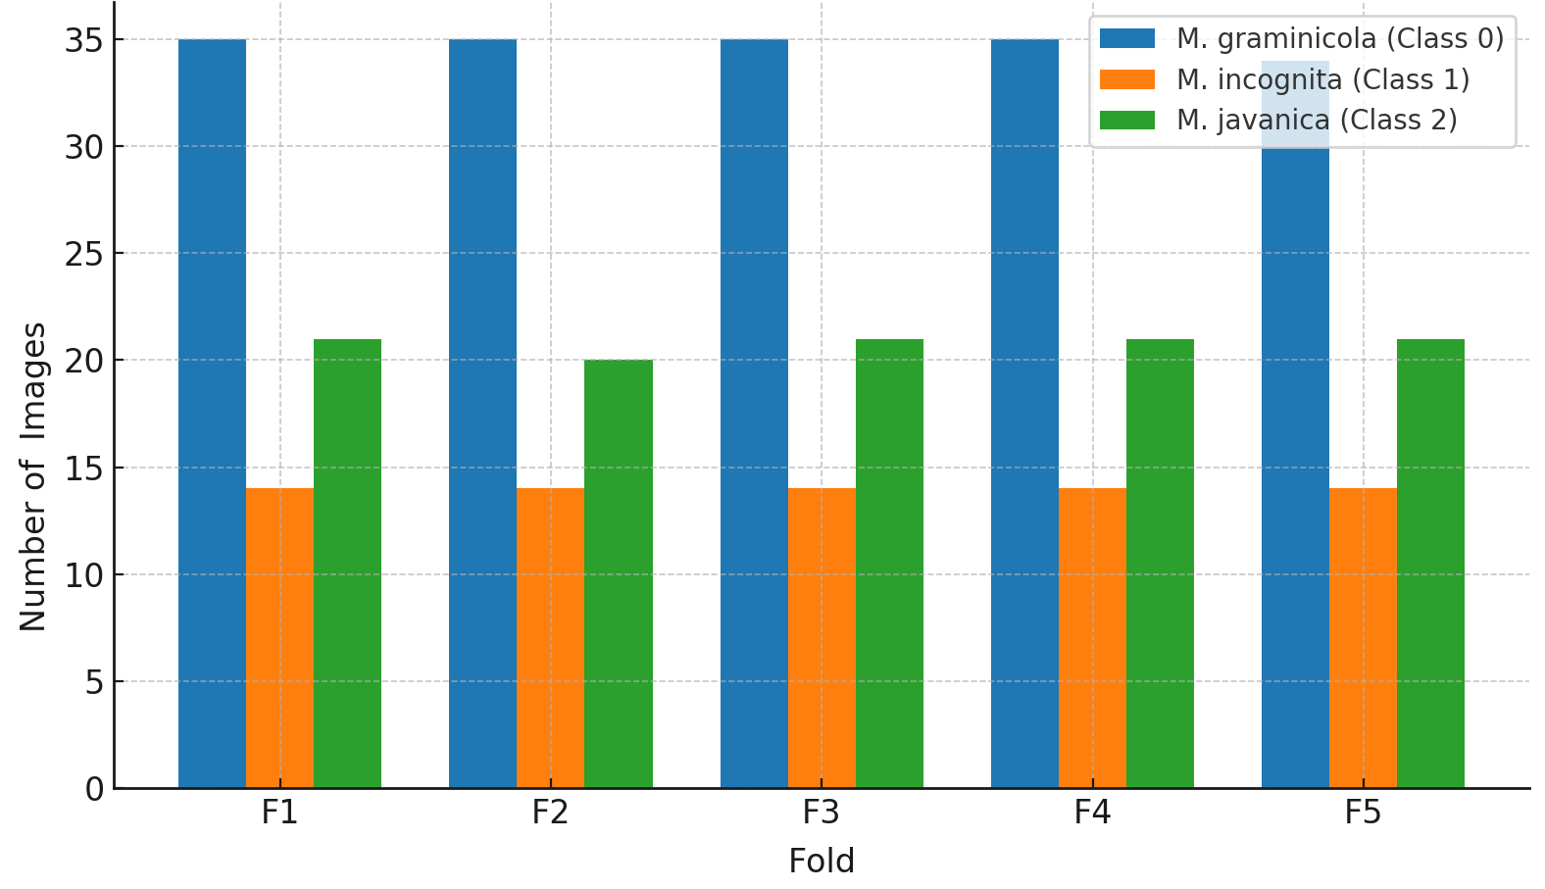
Figure S2. Bar chart showing the perineal pattern images stratified and evenly divided into five folds for cross-validation, while maintaining the class-wise distribution of M. graminicola (Class 0), M. incognita (Class 1), and M. javanica (Class 2).

Table S2. Comparative overview of CNN-based nematode identification models.

Feature / Aspect | Our Study (2024) | NemaNet (Abade et al., 2021) | NemaRec (Qing et al., 2021)
Target taxa | M. incognita, M. javanica, M. graminicola | Five PPNs from soybean (e.g., M. incognita, H. glycines) | 19 genera of soil nematodes
Taxonomic resolution | Species-level | Species-level | Genus-level
Image source | Perineal pattern images | Whole-body images (live nematodes in bright field) | Microscopy images (head, tail, full body)
Model architecture | AlexNet and VGG16 | Custom CNN (NemaNet) | ResNet101
Image annotation | Morphological and SCAR marker confirmed | Expert-labelled images | Morphological + ecological labelling
Training dataset size | 348 images (manually curated) | 7,500 images (1,500/species) | ~2,769 images (augmented)
Validation approach | 5-fold cross-validation | Train-test split (80/20) | Specimen and augmented datasets
Accuracy | ~95% | 96.6%–98.7% | 54–76% (specimen), up to 94% (augmented)
Comparison with human performance | Yes (3 annotators, Kappa, statistical tests) | No | No
Model interpretability | Yes (Integrated Gradients) | No | No
Web deployment | Not yet | No | Yes
Ecological index calculation | No | No | Yes (MI, PPI, feeding types)
Focus | Species-level diagnostics for RKNs | Field diagnosis of soybean PPNs | Environmental monitoring and soil health

